

Topic test
Name: __________________________________

Associations between variables

• Time allowed: 45 minutes
• Part A: 20 multiple-choice questions (20 marks)
• Part B: 6 free-response questions (30 marks)
• Total: 50 marks
Part A
20 multiple-choice questions
1 mark each: 20 marks
Circle the correct answer.

1 What type of data has 2 variables and is collected in pairs?
A Univariate B Bivariate
C Categorical D Nominal
2 Which of the following is an example of continuous data?
A Hair colour
B Shoe size
C Weight
D Ice cream flavour preference
Use the table below to answer questions 3–5.
The two-way table below shows the results of a survey about transport methods students took to school.
 | Walk | Bike | Bus | Car | Total
Boys |  | 17 |  | 28 | 129
Girls | 46 |  | 12
Total |  | 69 | 27 | 45
3 How many students were surveyed?
A 129 B 115
C 127 D 256
4 How many girls rode their bike to school?
A 17 B 52
C 69 D 127
5 How many students walked to school?
A 115 B 69
C 46 D 129
6 Identify what the total is when calculating the percentage of car owners who favour SUVs.
A SUV owners B Males
C Car owners D SUV owners
who are male
Use the table below to answer questions 7–9.
The two-way table below shows the preference of high school students for particular subjects.
 | Maths | Science | English | Total
Boys | 30
Girls | 26 |  | 40 | 100
Total |  | 80 | 72
7 What is the probability of a girl preferring science?
A 42.5% B 34%
C 16.3% D 38.5%
8 What is the probability of a science lover being a girl?
A 42.5% B 34%
C 16.3% D 38.5%
9 What is the probability of girl being a science lover?
A 42.5% B 34%
C 16.3% D 38.5%
10 The ‘Rule of 5’ states that:
A two-way tables must have 5 categories
B cell frequencies less than 5 are reliable
C cell frequencies less than 5 are unreliable
D cell frequencies more than 5 are unreliable
11 What is a true positive test result?
A A positive result that is correct
B A negative result that is wrong
C A negative result that is correct
D A positive result that is wrong
12 Which type of test result is the most serious error in pathological testing?
A True positive
B False positive
C True negative
D False negative
13 Which 2 results in pathological testing does the accuracy of the test determine?
A True positive and false positive
B True positive and true negative
C True negative and false negative
D False positive and false negative
Use the table below to answer questions
14–15.
The two-way table below shows the results of a study of the deaths of 20 000 women.
 | Breast Cancer
 | Yes | No
Hereditary | 1460 |  | 5000
Non-hereditary
 |  | 17 970 | 20 000
14 How many women died of breast cancer?
A 1460
B 15 000
C 2030
D 570
15 What is the risk of dying of breast cancer based on hereditary?
A 29.2%
B 71.9%
C 3.8%
D 28.1%

16 Which statement is false in regards to a positive association?
A Low values of the variable tend to be in the same pairs
B The graph of a positive association slopes upward from left to right
C High values of the variables tend to be in the same pairs
D As the value of one variable increases, the value of the second variable decreases
17 A non-linear association:
A is a straight-line
B is not a straight-line
C has a pattern but no clear line
D goes downwards from left to right
18 What type of association is shown in this scatterplot?
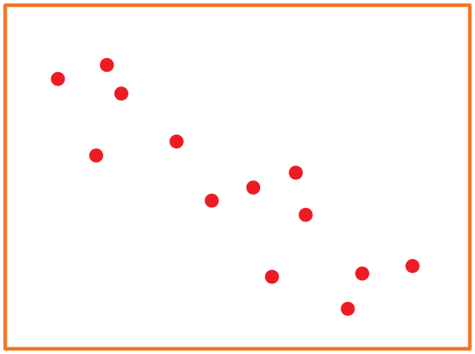
A Strong negative association
B Moderate positive association
C Weak negative association
D Moderate negative association

19 The covariance of x and y is 13.8 and their standard deviations are 4.3 and 6.9 respectively. What is the correlation coefficient?
A −0.47
B 22.14
C −22.14
D 0.47
20 The covariance of q and r is –6.6 and their standard deviations are 1.9 and 3.6 respectively.
Describe the apparent association.
A Moderate negative association
B Strong positive association
C Strong negative association
D Moderate positive association

Part B
6 free-response questions
30 marks
Show your working where appropriate.
21 This clustered bar graph shows the sales of appliances in 2 different stores.
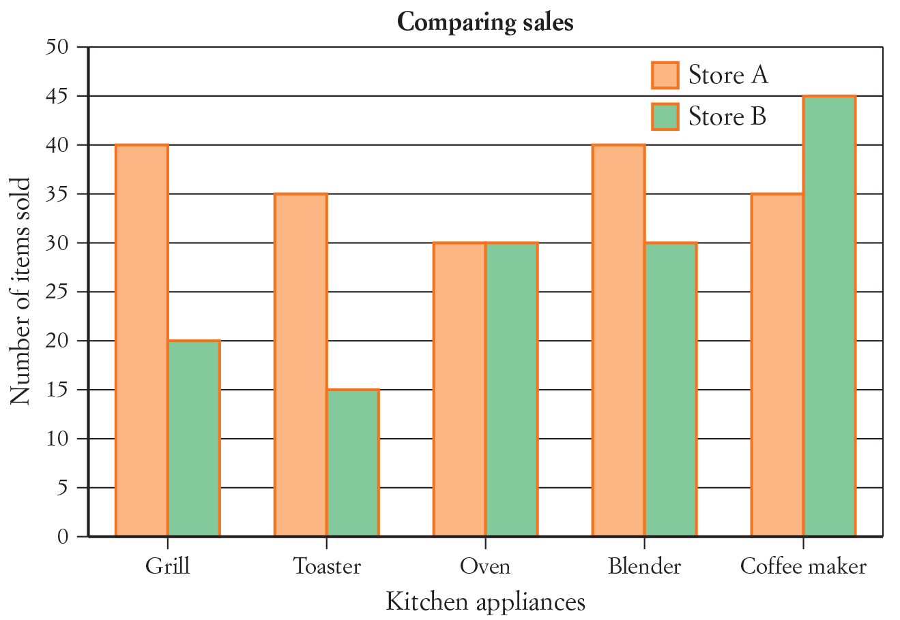
a Use the information in the graph to construct a two-way table.
b How many blenders were sold in total?
______________________________________________________________________________________
c What is the probability that the next person to shop at Store A would purchase a coffee maker?
______________________________________________________________________________________
d Of the next 700 people to shop at Store B, how many would you expect to buy a toaster?
______________________________________________________________________________________
[6 marks]

22 The data below shows the amount of time in hours that Year 12 students spent studying maths each week and their overall achievement as a grade.
2, D | 10, B | 7, C | 6, C | 14, B
12, B | 12, A | 10, C | 9, C | 7, D
18, A | 0, D | 17, B | 11, B | 6, C
4, C | 3, E | 20, A | 9, D | 9, C
8, C | 9, B | 5, D | 13, A | 12, C
a Construct a two-way table of this information using suitable categories for the time.
b What percentage of the Year 12 students studied very little?
______________________________________________________________________________________
[4 marks]
23 Complete this table that shows the types of food preferred by a group of Year 12 students.
 | Male | Female | Total
Mexican | 38 |  | 66
Asian |  | 34 | 61
Indian | 31 | 24
Total | 96
a Find the percentage of females who prefer Mexican.
______________________________________________________________________________________
b Find the percentage of students who prefer Mexican and are female.
______________________________________________________________________________________
c Find the percentage of Mexican food lovers who are female.
______________________________________________________________________________________
d Find the percentage of males who prefer Asian.
______________________________________________________________________________________
e Find the percentage of Asian food lovers who are male.
______________________________________________________________________________________
f From 350 students, how many would you expect to prefer Indian food?
______________________________________________________________________________________
[7 marks]

24 About 5% of the population suffers from the condition hypothyroidism and the pathology test for this condition is about 93% accurate.
a Set up a contingency table for test results and disease presence, assuming that test accuracy is not
affected by the presence of the disease.
b Find the probability that a positive result is false.
______________________________________________________________________________________
c Find the probability that a negative result is false.
______________________________________________________________________________________
[7 marks]
25 Ohm’s law is an important relationship in physics. It describes the association between current and voltage. Use the information in the table below to construct a scatterplot and hence describe the association between current and voltage in Ohm’s law.
Current | 1.0 | 2.1 | 3.0 | 4.0 | 5.0 | 6.0 | 7.0 | 8.0 | 9.0 | 10.0 | 11.0 | 12.0 | 13.0 | 14.0
Voltage | 0.4 | 0.3 | 0.6 | 0.6 | 0.4 | 1.0 | 0.9 | 0.7 | 1.0 | 1.1 | 1.3 | 1.1 | 1.4 | 1.6

_________________________________________________________________________________________
[3 marks]
26 The height and weight (to the nearest kg) of 10 friends is shown in the table below.
Height (cm) | 170 | 166 | 134 | 185 | 149 | 175 | 156 | 163 | 180 | 140
Weight (kg) | 82 | 50 | 47 | 89 | 82 | 74 | 54 | 59 | 94 | 65
Use a calculator to find the covariance and standard deviations of the data set and then describe the association between these data sets by calculating the correlation coefficient.
_________________________________________________________________________________________
_________________________________________________________________________________________
[3 marks]

This is the end of the test.
Use the rest of this page and the back for extra working space.
Answers
1 B 2 C 3 D 4 B 5 A
6 C 7 B 8 A 9 C 10 C
11 A 12 D 13 B 14 C 15 A
16 D 17 B 18 D 19 D 20 C
21 a
 | Appliance
 | Grill | Toaster | Oven | Blender | Coffee maker | Total
Store A | 40 | 35 | 30 | 40 | 35 | 180
Store B | 20 | 15 | 30 | 30 | 45 | 140
Total | 60 | 50 | 60 | 70 | 80 | 320
b 70
c P(store A coffee) = × 100 = 19.4%
d E(store B toaster) = × 700 = 75 people
22 a
 |  | HOURS OF STUDY
 | Low (< 8 h) |  | Medium (8–12 h) |  | High (>12 h) |  | Total
A |  | 0 |  | 1 |  | 3 |  | 4
B |  | 0 |  | 4 |  | 2 |  | 6
C |  | 4 |  | 5 |  | 0 |  | 9
D |  | 4 |  | 1 |  | 0 |  | 5
E |  | 1 |  | 0 |  | 0 |  | 1
Total |  | 9 |  | 11 |  | 5 |  | 25
b × 100 = 36%
23 a
 | Male | Female | Total
Mexican | 38 | 28 | 66
Asian | 27 | 34 | 61
Indian | 31 | 24 | 55
Total | 96 | 86 | 182
b P(F, Mexican) = × 100 = 32.6%
c P(S, Mexican) = × 100 = 15.4%
d P(Mexican, F) = × 100 = 42.4%
e P(M, Asian) = × 100 = 28.1%
f P(Asian, M) = × 100 = 44.3%
E(S, Indian) = × 100 = 30.2%
24 a
 |  | Hypothyroidism
 |  | Yes | No | Total
Test Result | Positive | 4.65% | 6.65% | 11.3%
Test Result | Negative | 0.35% | 88.35% | 88.7%
 | Total | 5% | 95% | 100%
b P(+, F) = × 100 = 58.8%
c P(−, F) = × 100 = 0.4%
25 The points slope upwards as we move from left to right, therefore there is a moderate positive association between current and voltage.
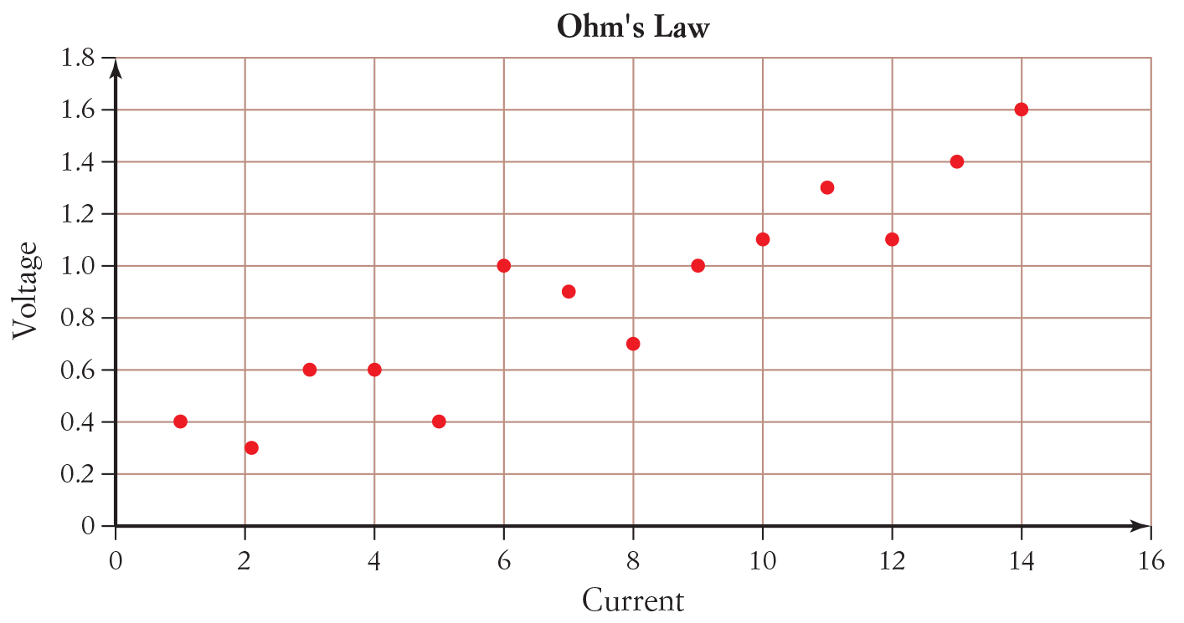
26 COV(h, w) = 179.91 StDev(h) = 16.92 StDev(w) = 16.9
r =
r =
r = 0.63
r is a positive number, therefore it is a positive association and r is below 0.7, therefore it is a moderate association.
The association between height and weight is a moderate positive association.

